**ST. XAVIER’S COLLEGE**

**MAITIGHAR, KATHMANDU**



**DBMS**

**Theory Assignment #4**

**Submitted by:**

Anu Kadel

013BSCIT007

**Submitted to:**

|  |  |
| --- | --- |
| **Er. Sanjay Kumar Yadav** |  |

Lecturer

Department of Computer Science

St. Xavier’s College, Maitighar

**THEORY ASSIGNMENT#4**

**ER DIAGRAM/MODEL**

The whole purpose of ER modeling is to create an accurate reflection of the real world in a database. The ER model doesn’t actually give us a database description. It gives us an intermediate step from which it is easy to define a database

An entity relationship diagram (ERD) shows the relationships of entity sets stored in a database. An entity in this context is a component of data. In other words, ER diagrams illustrate the logical structure of databases.

At first glance an entity relationship diagram looks very much like a [flowchart](http://www.smartdraw.com/flowchart/). It is the specialized symbols, and the meanings of those symbols, that make it unique

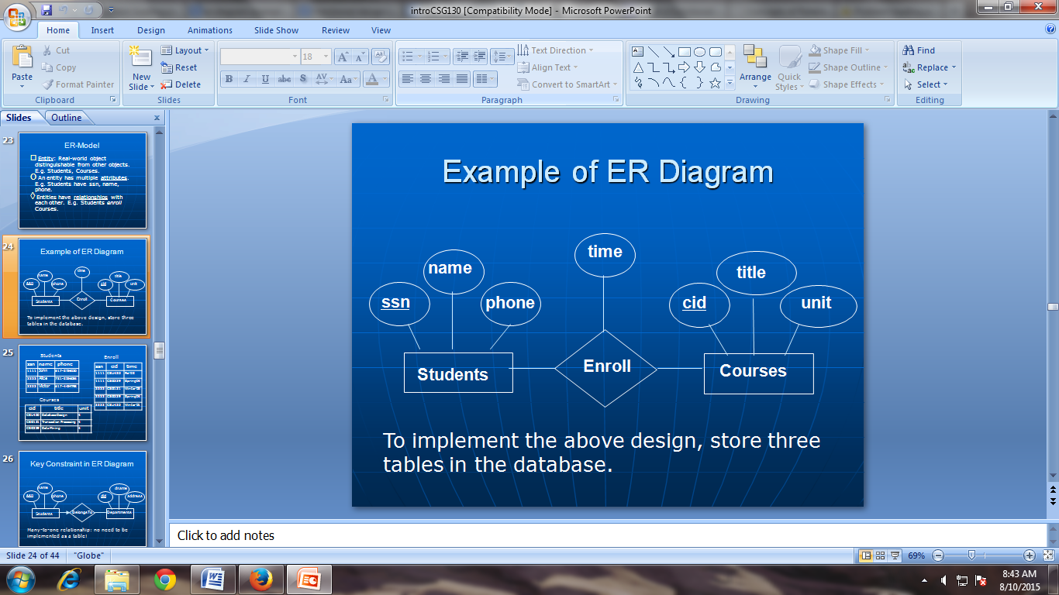

Fig: Example of ER Diagram

**DESIGN**

*Design* refers to the planning that is the foundation of making things. There are different design philosophies, approaches, and methods

1. **Functional design**

Functional design is used to mean that the product’s functionality is taken into account in important ways as it is imagined and built. For a product to end up being functional, both the end user and the client need to be considered all the way through the design process. It may take some work to describe the target audience accurately.

Functional design is a design method in which the system is seen from the functional viewpoint. The design concentrates on isolating high-level functions that can then be decomposed into and synthesized from lower-level functions.

1. **Database design**

**Database design** is the process of producing a detailed data model of a database. This logical data model contains all the needed logical and physical design choices and physical storage parameters needed to generate a design in a data definition language, which can then be used to create a database.

In the picture below there are the main phases of database design. Database design is connected with application design.

**2.1. Conceptual Design**

Once all the requirements have been collected and analyzed, the next step is to create a conceptual shema for the database, using a high level conceptual data model. This phase is called conceptual design.  
  
The result of this phase is an Entity-Relationship (ER) diagram or UML class diagram. It is a high-level data model of the specific application area. It describes how different entities (objects, items) are related to each other. It also describes what attributes (features) each entity has. It includes the definitions of all the concepts (entities, attributes) of the application area.  
  
During or after the conceptual schema design, the basic data model operations can be used to specify the high-level user operations identified during the functional analysis. This also serves to confirm that the conceptual schema meets all the undefined functional requirements.  
  
There are several notations to draw the ER diagram.

* 1. **Logical Design**

The result of the logical design phase (or data model mapping phase) is a set of relation shcemas. The ER diagram or class diagram is the basis for these relation schemas.  
  
To create the relation shemas is quite a mechanical operation. There are rules how the ER model or class diagram is transferred to relation shemas.  
  
The relation schemas are the basis for table definitions. In this phase (if not done in previous phase) the primary keys and foreign keys are defined.

**2.2.2 Normalization**

Normalization is the last part of the logical design. The goal of normalization is to eliminate redundancy and potential update anomalies.  
  
Redundancy means that the same data is saved more than once in a database. Update anomaly is a consequence of redundancy. If a piece of data is saved in more than one place, the same data must be updated in more than one place.  
  
Normalization is a technique by which one can modify the relation schema to reduce the redundancy. Each normalization phase adds more relations (tables) into the database.

* 1. **Physical Design**

The goal of the last phase of database design, physical design, is to implement the database. At this phase one must know which database management system (DBMS) is used. For example, different DBMS's have different names for datatypes and have different datatypes.

**CHARACTERISTICS OF RELATIONS**

## A relational database is a collection of data items organized as a set of formally-described tables from which data can be accessed or reassembled in many different ways without having to reorganize the database tables

The relational model for [database](https://en.wikipedia.org/wiki/Database) management is a [database model](https://en.wikipedia.org/wiki/Database_model) based on [first-order predicate logic](https://en.wikipedia.org/wiki/First-order_logic), first formulated and proposed in 1969 by [Edgar F. Codd](https://en.wikipedia.org/wiki/Edgar_F._Codd). In the relational model of a database, all data is represented in terms of [tuples](https://en.wikipedia.org/wiki/Tuple), grouped into [relations](https://en.wikipedia.org/wiki/Relation_%28database%29). A database organized in terms of the relational model is a [relational database](https://en.wikipedia.org/wiki/Relational_database).

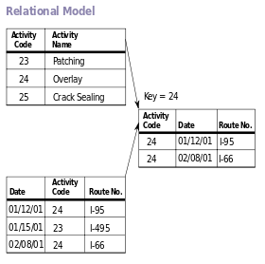

Fig: Diagram of an example database according to the Relational model

* A relational database is a set of tables containing data fitted into predefined categories. Each table (which is sometimes called a *relation*) contains one or more data categories in columns.
* Each [row](http://searchoracle.techtarget.com/definition/row) contains a unique instance of data for the categories defined by the columns.
  + For example, a typical business order entry database would include a table that described a customer with columns for name, address, phone number, and so forth.
  + Another table would describe an order: product, customer, date, sales price, and so forth.
* A user of the database could obtain a [*view*](http://searchsqlserver.techtarget.com/definition/view) of the database that fitted the user's needs.
  + For example, a branch office manager might like a view or report on all customers that had bought products after a certain date.
  + A financial services manager in the same company could, from the same tables, obtain a report on accounts that needed to be paid.

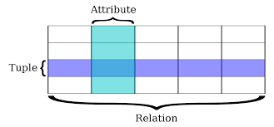

**ER to Relational Mapping Algorithm**

Step1: Mapping of regular entity types

Step2: Mapping of weak entity type

Step3: Mapping of binary 1:1 relation types

Step4: Mapping of binary 1:N relation types

Step5: Mapping of binary M:N relation types

Step6: Mapping of multi-valued attributes

Step7: Mapping of N-ary relationship types

REFERENCES

[1] <http://www.encyclopedia.com/doc/1O11-functionaldesign.html>

[2] <http://www.tutorialspoint.com/dbms/relational_data_model.htm>